Ada-Boost is adaptive boosting.

Its most successful application is in face detection but is also used other than image processing too.

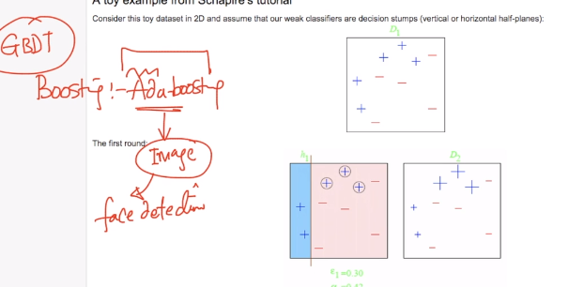

Now lets take an example to understand the geometric intuition for Ada-Boosting.

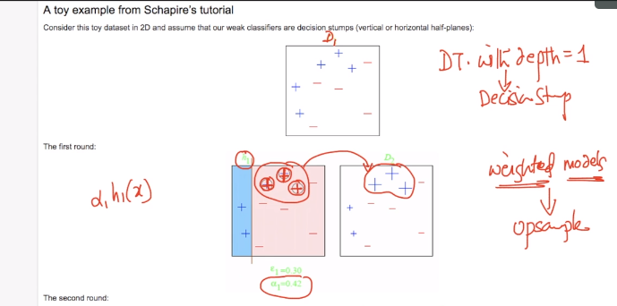

So here in first round that is basically the output we got after training the data using DT or any other algo.

So we can see that in D1 we got 3 positive points as wrongly classified and so now what we can do is we will increase the weight for those points and use it as input for second round.

We increase the weight exponentially in Ada-Boosting.

So when we do this the algorithm will be able to correctly classify the positive points because of increased weights.

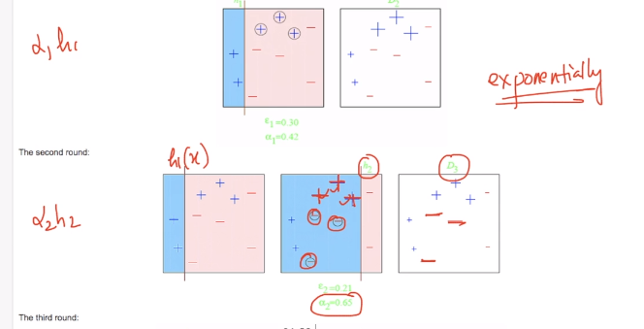

But now it will wrongly classify few negative points and so we will create new data set by increasing the weights of negative points and will use that data set as input for next round.

Now we will continue the process

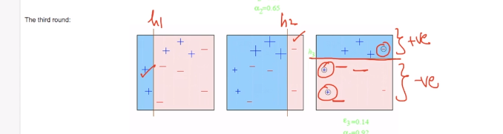

As we can see in above image that the errors in final output can be taken care by h1 and h2

and at final we will add all the models so as to get the best model.

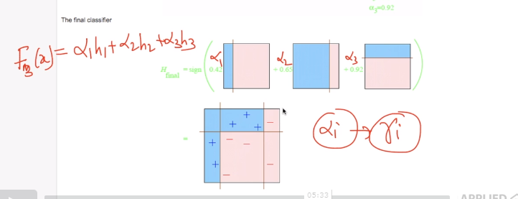

In case of GBDT we used pseudo residual computed from negative gradient of the loss function while here all the points which are misclassified are given more weightage with Ada-Bossting. And the name is just the reflection of process we are following i.e. we are just adapting the errors we get after training the model.

BUT in internet companies GBDT are more extensively used than Ada-Boosting.

**Comments:**

